Registration Checklist

If you are interested in registering with Troop XYZ, the following forms are required:
- Completed Online Youth Application and Registration Fee | 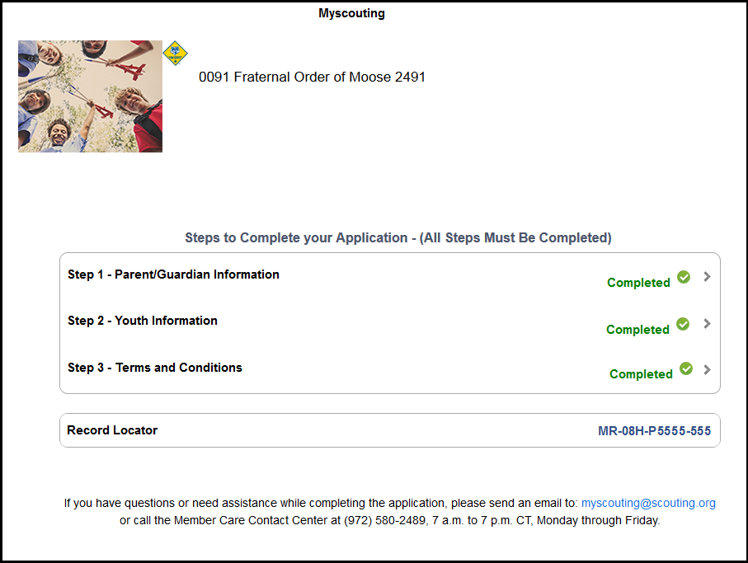
- Troop Dues  - Check made to “Troop XYZ”  - See Troop XYZ Guidelines for current rate | 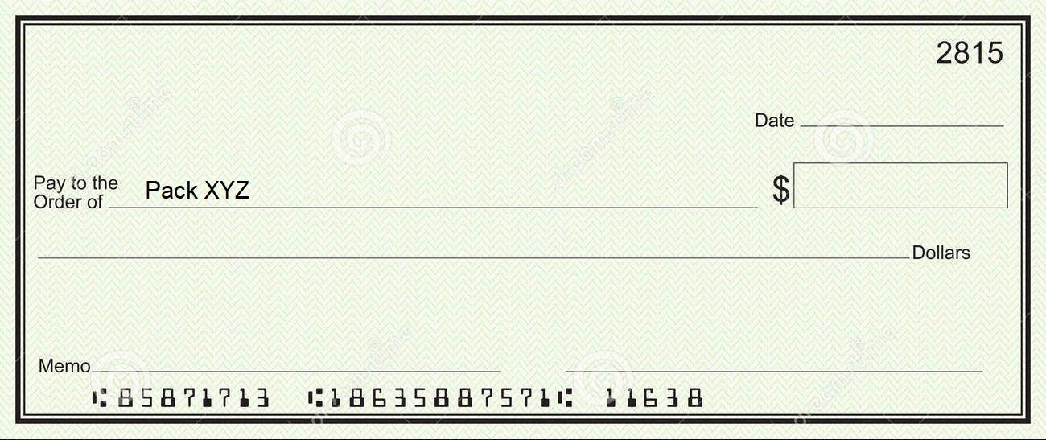
- Signed Permission to Use and Publish Photos  - Please include all immediate family members that may attend Troop events  - Email to Membership Chair | 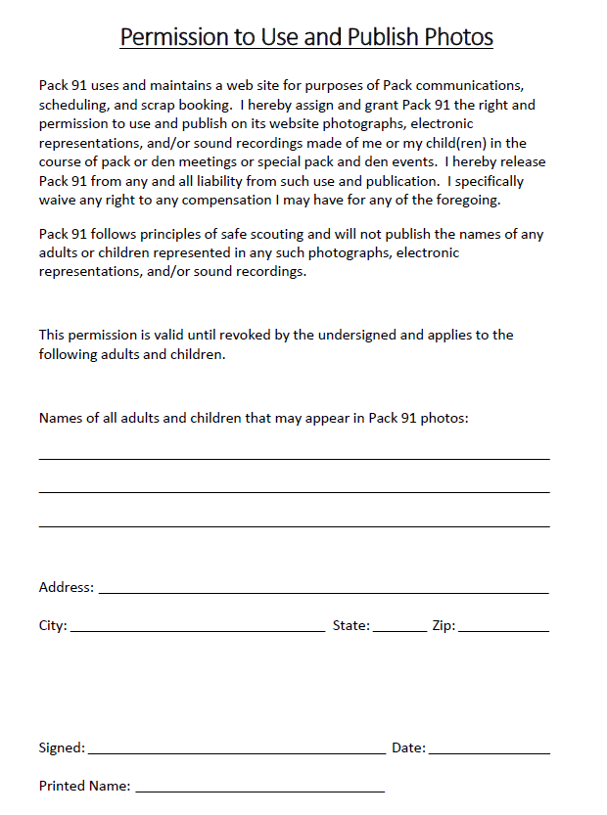

- Completed Medical Forms A, B, and C  - 4 pages total  - Form C will require a doctor’s signature  - Please submit hard copy in a sealed envelope labeled with scout’s name  - Keep a copy for yourself. The Troop will need a new copy every year, as will most Rainbow Council events. | 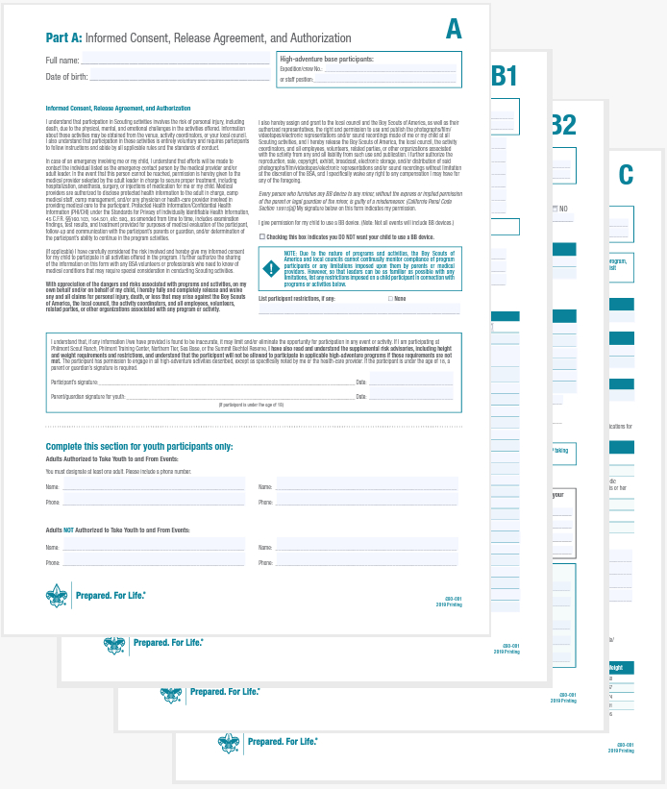
- Copy of Insurance Card (front and back)  - Required as part of Medical Form B  - Please submit hard copy in a sealed envelope labeled with scout’s name  - Keep a copy for yourself. The Troop will need a new copy every year, as will most Rainbow Council events. | 

