Registration Checklist

If you are interested in registering with Pack XYZ, the following forms are required:
- Completed Online Youth Application and Registration Fee | 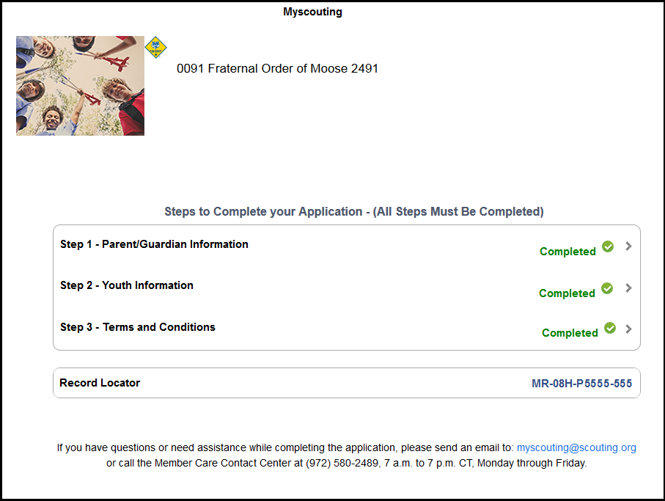
- Pack Dues  - Check made to “Pack XYZ”  - See Pack XYZ Guidelines for current rate | 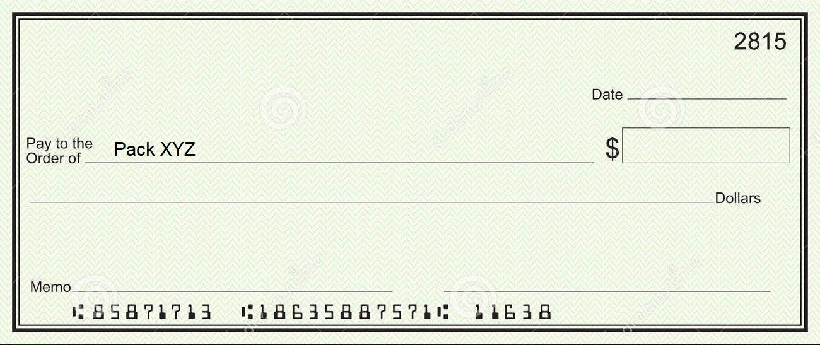
- Signed Pack XYZ Guidelines Signature Page  - Email to Membership Chair | 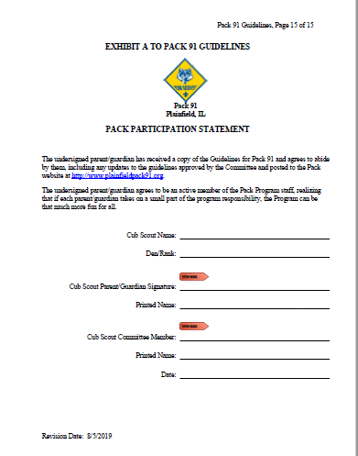
- Signed Pack XYZ Code of Conduct Signature Page  - Review with Den Leader  - Email to Membership Chair | 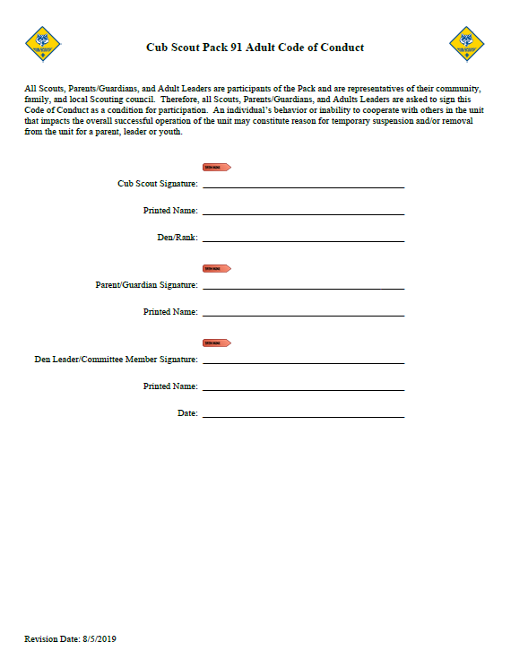
- Signed Permission to Use and Publish Photos  - Please include all immediate family members that may attend Pack events  - Email to Membership Chair | 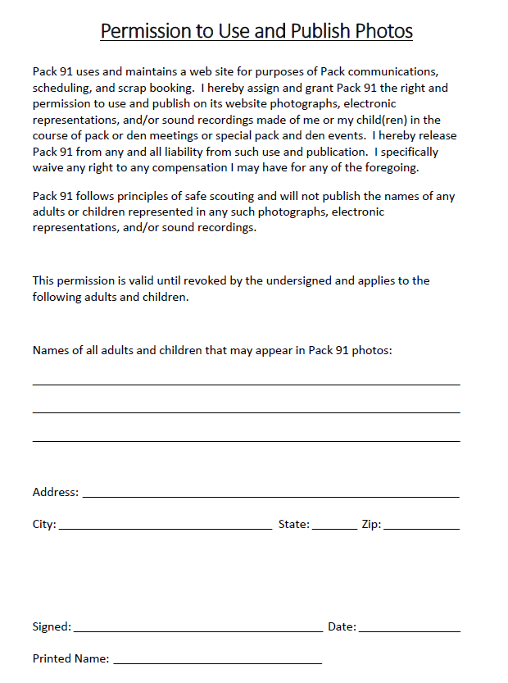

Required Forms Continued:
- Den Placement Form  - Please submit hard copy | 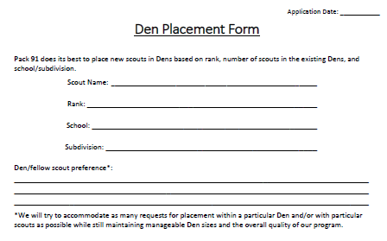
- Completed Medical Forms A and B  - 3 pages total  - Does not require a doctor’s signature  - Please submit hard copy in a sealed envelope labeled with scout’s name  - Keep a copy for yourself. The Pack will need a new copy every year, as will most Rainbow Council events. | 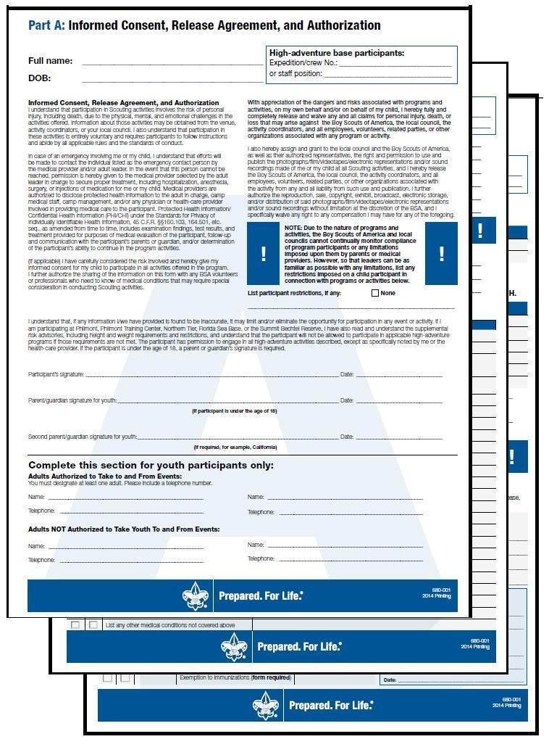
- Copy of Insurance Card (front and back)  - Required as part of Medical Form B  - Please submit hard copy in a sealed envelope labeled with scout’s name  - Keep a copy for yourself. The Pack will need a new copy every year, as will most Rainbow Council events. | 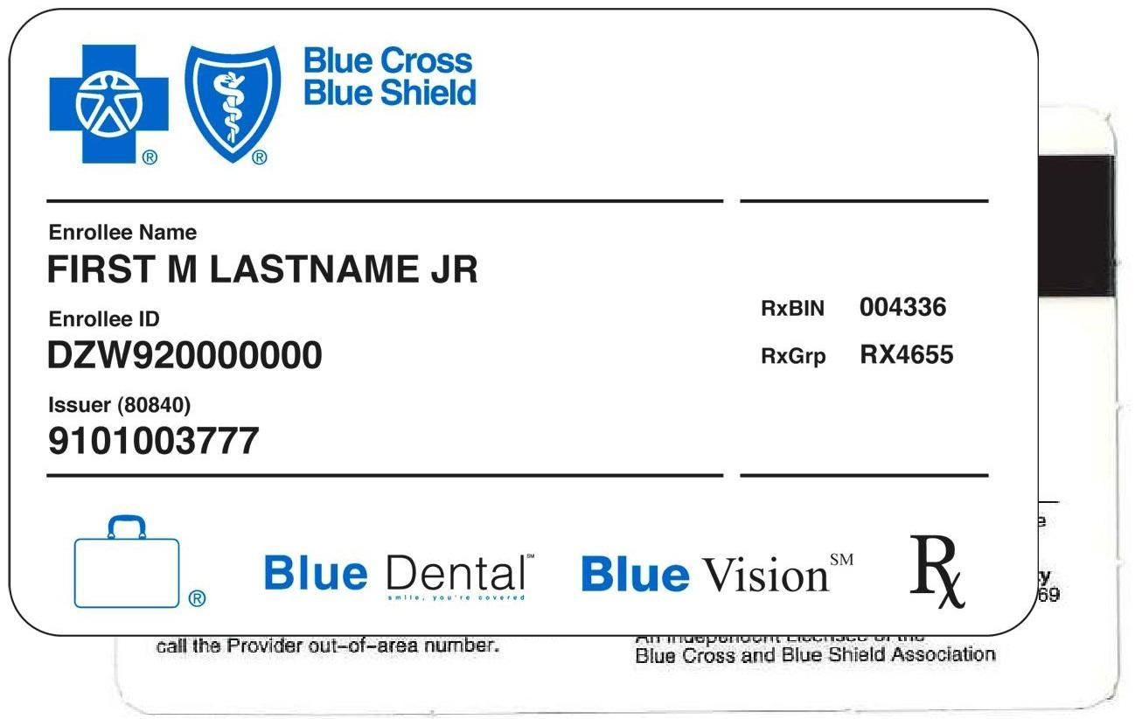

The following forms are optional:
- Additional Contact Form  - Submit hard copy or email details to Membership Chair | 

